**Assignment-1**

**Name : m.harshini**

**Reg no : 121011012776**

**Subject : data science**

**Degree :btech**

**Branch :cse 2nd year**

**Topic :Lorenz curve and paper-pencil**

**test**

**Date :17-02-2023**

**Lorenz curve**

**Definition:**

The Lorenz curve is a graphical representation of an [**economic inequality**](https://www.wallstreetmojo.com/economic-inequality/) model. The curve takes the population percentile on the X-axis and cumulative wealth on the Y-axis. Complementing this graph would be a diagonal line at a 45⁰ angle from the origin (meeting point of the X and Y axis), indicating the population’s perfect income or wealth distribution.

The area enclosed between the line and this curve is the precise measurement of inequality. The area between the two lines expressed as a ratio to the area under the straight line represents the inequality. It is called the [**Gini coefficient**](https://www.wallstreetmojo.com/gini-coefficient/)

**Components of the Lorenz Curve**

There are several important components to understand when analyzing a Lorenz curve:

* The *x-axis* is often denoted as the percentile. In the graph above, the x-axis is the percentile of net worth ranking compared to other U.S. households.
* The *y-axis* is often denoted as the cumulative percentage of occurrences. In the graph above, the percentages represent the cumulative amount of net worth of households.
* The *line of equality* is demonstrated by a 45-degree, upward-sloping line. In the graph above, it is denoted as the dashed line.
* The *Lorenz curve* is demonstrated often by an upward-sloping but often exponentially rising curve. In the graph above, it is denoted as a solid line.
* The Gini coefficient (discussed below) is the gap between the line of equality and the Lorenz curve.

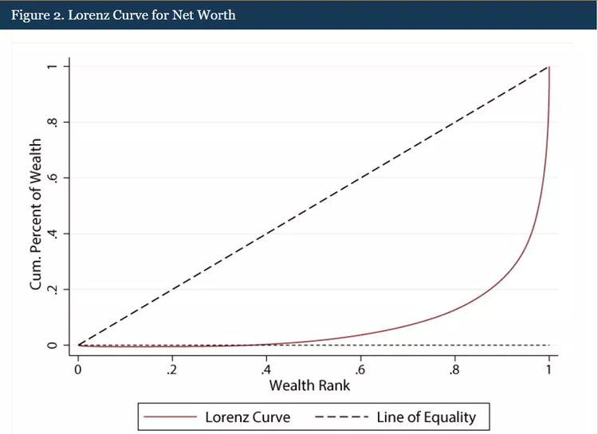

**The Lorenz Curve and the Gini Coefficient**

The [Gini coefficient](https://www.investopedia.com/terms/g/gini-index.asp) is used to express the extent of inequality in a single figure. It most often ranges from 0 (or 0%) to 1 (or 100%). Complete equality, in which every individual has the exact same income or wealth, corresponds to a coefficient of 0. Plotted as a Lorenz curve, complete equality would be a straight diagonal line with a slope of 1 (the area between this curve and itself is 0, so the Gini coefficient is 0).

A coefficient of 1 means that one person earns all of the income or holds all of the wealth.3 In theory, the Gini coefficient can exceed 100% in extreme situations. For example, when handling negative wealth or income, the figure can theoretically be higher than 1; in that case, the Lorenz curve would dip below the horizontal axis.

The Gini coefficient is equal to the area below the line of perfect equality minus the area below the Lorenz curve, divided by the area below the line of perfect equality. In the graph above, the Gini coefficient is the area below the dashed line but above the solid line. The Gini coefficient is used to measure the extent of inequality. It can also be used to compare two different nations or countries to see which has more inequality.

### Uses of the Lorenz Curve

* One can use it to show the effectiveness of a government policy in helping redistribute income. The impact of a particular policy introduced can be demonstrated with the help of the Lorenz curve, how the curve has moved closer to the perfect equality line post-implementation of that policy.
* It is one of the simplest representations of inequality.
* It is most useful in comparing the variability of two or more distributions.
* It shows the distribution of wealth of a country among different percentages of the population with the help of a graph that helps many businesses establish their target bases.
* It helps in business modeling.
* One can use it majorly while taking specific measures to develop the weaker sections of the economy.

### Limitations

* It might not always be rigorously true for a finite population level.
* The equality measure shown may be misleading.
* When two Lorenz curves are being compared and intersected, it is impossible to ascertain which distribution represented by the curves displays more inequality.
* The Lorenz curve ignores income variation over an individual’s lifecycle while determining inequality.

### Conclusion

the Lorenz curve provides an innate and complete understanding of the income distribution. Moreover, it provides the basis for inequality measurements through the Gini index.

The curve defines the relationship between the cumulative portions of income as received by the cumulative population when the income-earning population is arranged in ascending order.

The extent to which the curve bulges downward below the straight diagonal line called the line of equality indicates the degree of inequality of distribution. It implies the curve will always be bowed downwards until there exists inequality in the economy.

Though considered the simplest among other disparities measures, the graph can be misleading and might not always produce accurate results.

**Paper-and-pencil test : An efficient method of assessment**

**An efficient method of assessment**

Paper-and-pencil instruments refer to a general group of assessment tools in which candidates read questions and respond in writing. This includes tests, such as knowledge and ability tests, and inventories, such as personality and interest inventories.

Paper-and-pencil tests can be used to assess job-related knowledge and ability or skill qualifications. The possible range of qualifications which can be assessed using paper-and-pencil tests is quite broad. For example, such tests can assess anything from knowledge of office procedures to knowledge of federal legislation, and from the ability to follow directions to the ability to solve numerical problems.

Because many candidates can be assessed at the same time with a paper-and-pencil test, such tests are an efficient method of assessment.

**Developing paper-and-pencil tests: 4 basic steps.**

All assessment methods must provide information that is relevant to the qualification(s) being assessed. The following 4 steps ensure that paper-and-pencil tests provide this information.

**Step #1**

Listing topic areas/tasks

**Step #2**

Specifying the response format, number of questions, the time limit and difficulty level

**Step #3**

Writing the questions and developing the scoring guide

**Step #4**

Reviewing the questions and scoring guide

***Thank you***